

**Capstone Project Report**

**Report 3 – Software Requirement Specification**

– Ho Chi Minh City, October 2025 –

**Table of Contents**

I. Record of Changes 3

II. Software Requirement Specification 4

1. Product Overview 4

2. User Requirements 5

2.1 Actors 5

2.2 Use Cases 5

3. Functional Requirements 7

3.1 System Functional Overview 7

3.2 <<Feature Name 1>> 9

3.3 <<Feature Name 2>> 9

4. Non-Functional Requirements 10

4.1 External Interfaces 10

4.2 Quality Attributes 10

5. Requirement Appendix 11

5.1 Business Rules 11

5.2 Common Requirements 14

5.3 Application Messages List 14

5.4 Other Requirements… 14

# I. Record of Changes

|  |  |  |  |
| --- | --- | --- | --- |
| Date | A* M, D | In charge | Change Description |
|  |  |  |  |
|  |  |  |  |
|  |  |  |  |
|  |  |  |  |
|  |  |  |  |
|  |  |  |  |
|  |  |  |  |
|  |  |  |  |
|  |  |  |  |
|  |  |  |  |
|  |  |  |  |
|  |  |  |  |
|  |  |  |  |

*A - Added M - Modified D - Deleted

# II. Software Requirement Specification

## 1. Product Overview

*[Gives the overall description about the product with some introduction and the context diagram. The context diagram presents the boundary and connections between the system you’re developing and everything else in the universe. This identifies external entities (or terminators – software, hardware, human components, and other systems) outside the system that interface to it in some way, as well as data, control, and material flows between the terminators and the system.]*

<<Sample: The Cafeteria Ordering System is a new software system that replaces the current manual and telephone processes for ordering and picking up meals in the Process Impact cafeteria. The context diagram below illustrates the external entities and system interfaces for release 1.0. The system is expected to evolve over several releases, ultimately connecting to the Internet ordering services for several local restaurants and to credit and debit card authorization services.

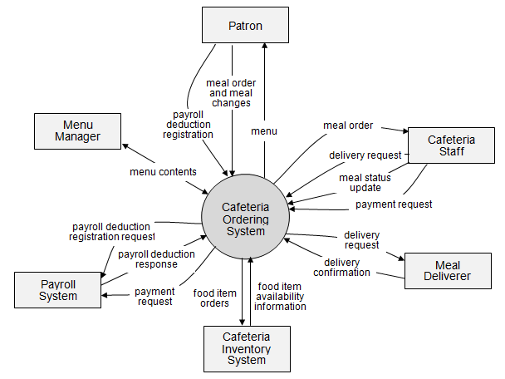

>>

## 2. User Requirements

### 2.1 Actors

|  |  |  |
| --- | --- | --- |
| **#** | **Actor** | **Description** |
| 1 | Administrator |  |
| 2 | Simulation Manager |  |
| 3 | Instructor |  |
| 4 | Trainee |  |

### 2.2 Use Cases

#### 2.2.1 Diagram(s)

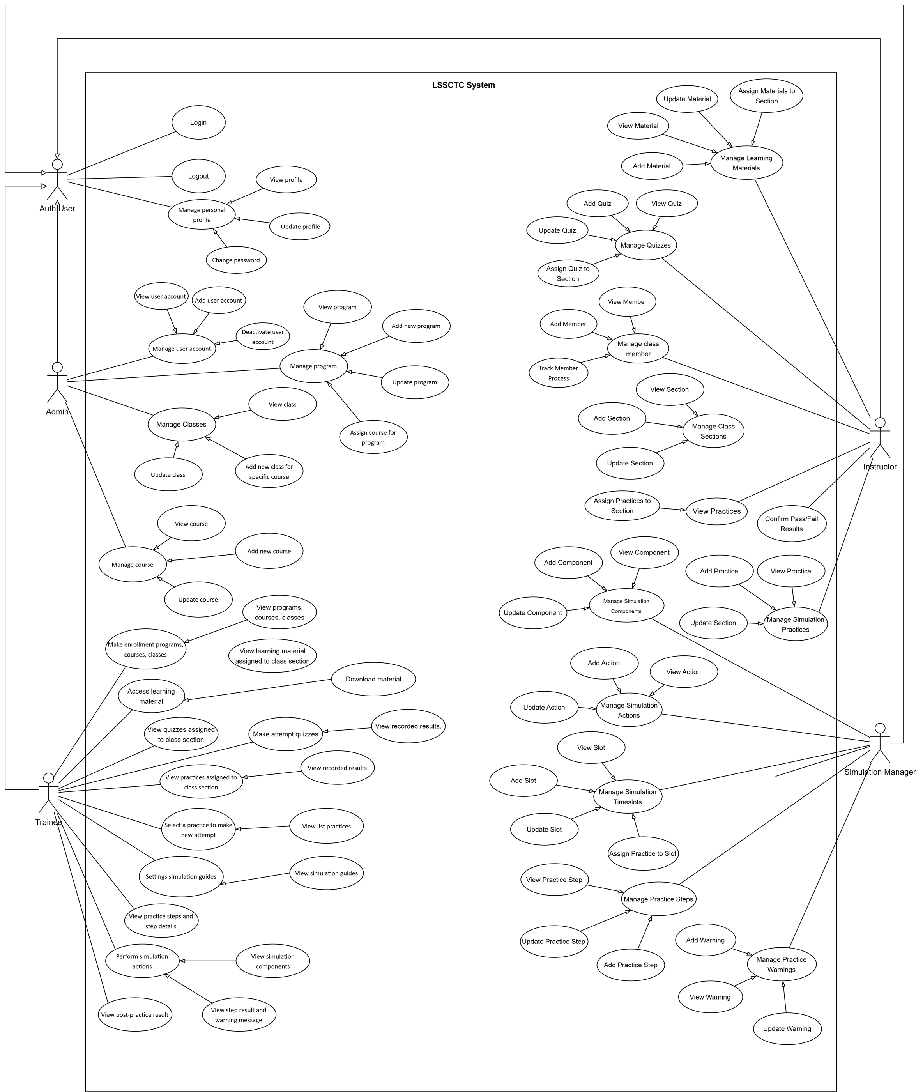

#### 2.2.2 Descriptions

*This part describes the use cases, you can follow the table form as below]*

|  |  |  |  |
| --- | --- | --- | --- |
| **ID** | **Use Case** | **Actors** | **Use Case Description** |
| 01 | View Menu | Patron |  |
| 02 | Order a Meal | Patron |  |
| 03 | … |  |  |

## 3. Functional Requirements

### 3.1 System Functional Overview

*[Provide functionality overview of software system: screen flow, screen descriptions, system user roles, screen authorization, non-screen functions, ERD]*

#### 3.1.1 Screens Flow

*[This part shows the system screens and the relationship among screens. You can draw the Screens Flow for the system in the form of diagram as below. Please note that beside the normal flat screen, we might have the oval notation for pop-up screen (Import Order) or a screen with multiple information tab (Order Details), etc. You may also use text or background format for different visuality purpose]*

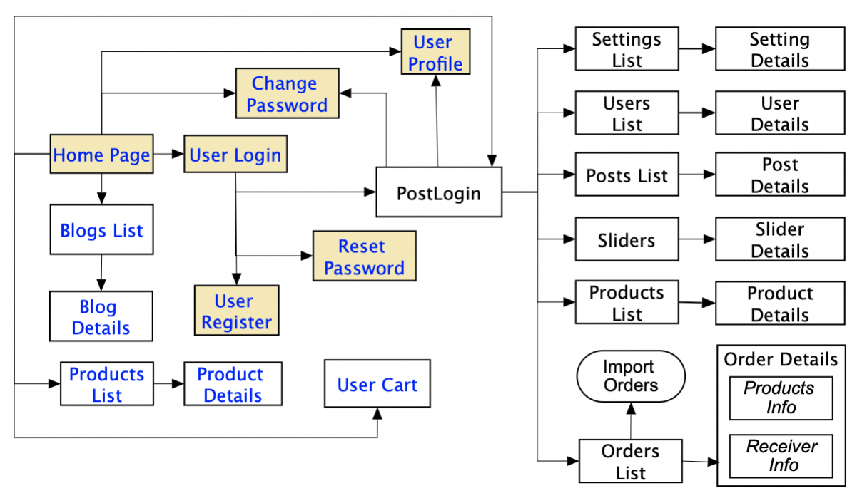

#### 3.1.2 Screen Descriptions

*[Provide the descriptions for the screens in the Screens Flow above]*

|  |  |  |  |
| --- | --- | --- | --- |
| **#** | **Feature** | **Screen** | **Description** |
| 1 | Order Meals | Create Order | <<Screen Brief description>> |
| 2 | Order Meals | Change Order |  |
| 3 | .. |  |  |

#### 3.1.3 Screen Authorization

|  |  |  |  |  |
| --- | --- | --- | --- | --- |
| **Screen** | **Role-Name1** | **Role-Name2** | **Role-Name3** | **…** |
| <<Screen Name1>> | X |  | X | X |
| <<Screen Activity>> |  |  | X | X |
| <<Screen Name2>> | X |  | X |  |
| Query All Data | X |  |  |  |
| Query Own Data |  |  | X |  |
| Query Managed Data |  |  | X |  |
| Add New Data |  |  | X | X |
| Update All Data |  |  |  | X |
| Update Own Data |  |  |  | X |
| Update Managed Data |  |  |  | X |
| Delete Data |  |  |  |  |
| … |  |  |  |  |

#### 3.1.4 Non-Screen Functions

|  |  |  |  |
| --- | --- | --- | --- |
| **#** | **Feature** | **System Function** | **Description** |
| 1 | <<Feature Name>> | <<Function Name1>> | <<Function Name1 Description>> |
| 2 | … |  |  |

#### 3.1.5 Entity Relationship Diagram

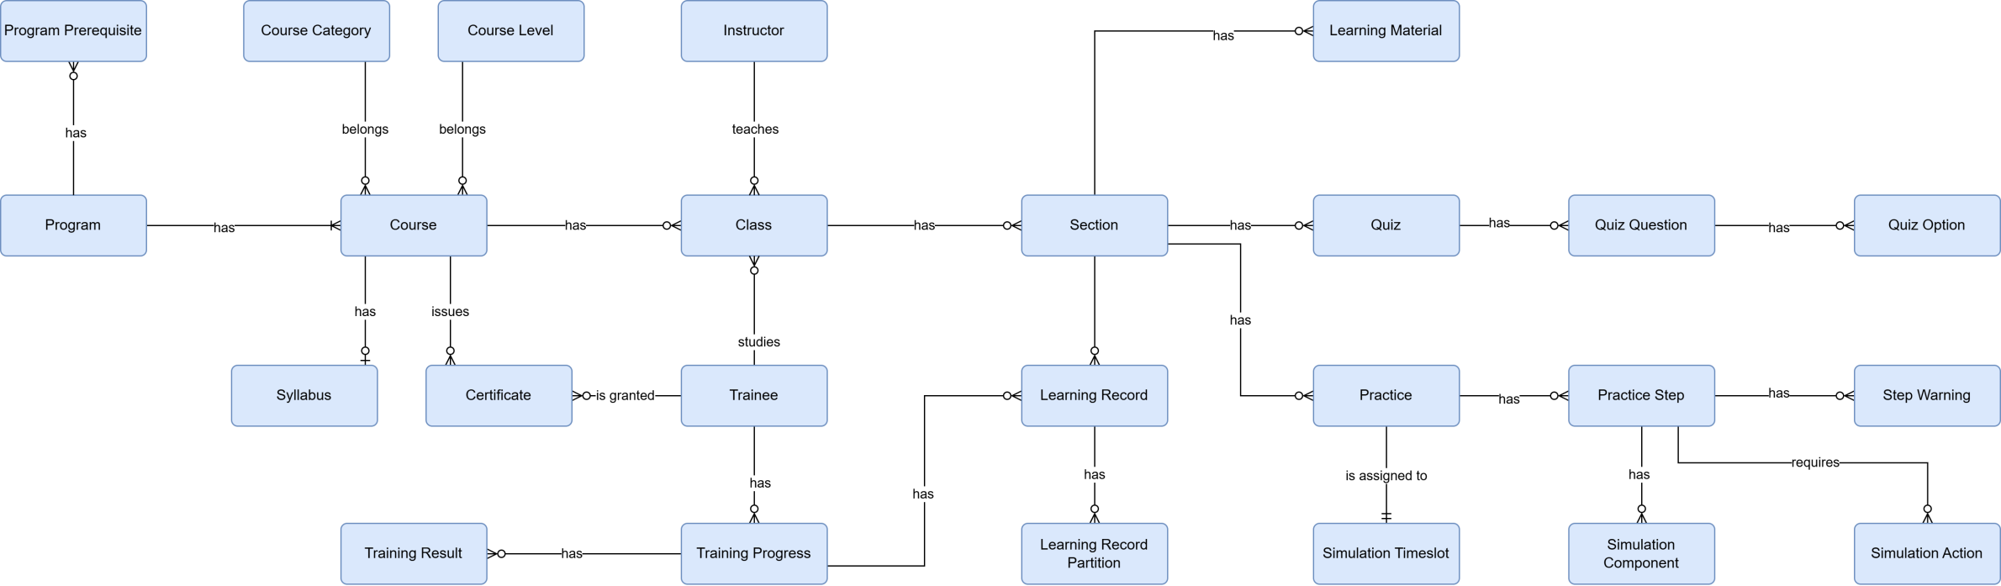

### 3.2 <<Feature Name 1>>

#### 3.2.1 <<Function Name 1>>

*[A function can be a screen or a non-screen function (listed in the part 3.1.5 above). In this part, you need to provide the details on the related function, focus on mentioning below information*

* *Function trigger: how this function is triggered (navigation path, a timing frequency, etc.*
* *Function description: actors/roles, purpose, interface, data processing, etc.*
* *Screen layout: mock-up prototype of the screen, sample below is for Manage Products screen*

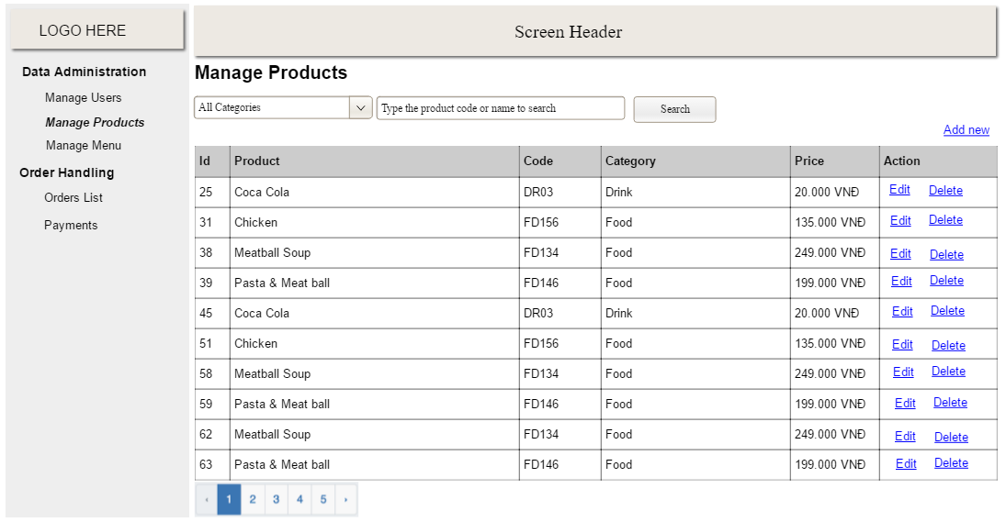

* *Function Details: provide explanation for the data, validation, business rules, functionalities (for both normal cases and abnormal cases), etc. of the function so that the reader can image how it work.*

*]*

#### 3.2.2 <<Function Name 2>>

…

### 3.3 <<Feature Name 2>>

…

## 4. Non-Functional Requirements

### 4.1 External Interfaces

*[This section provides information to ensure that the system will communicate properly with users and with external hardware or software/system elements.]*

### 4.2 Quality Attributes

*[List all the required system characteristics (quality attributes) specification. Some of the possible attributes are provided with the guide/descriptions are mentioned here]*

#### 4.2.1 Usability

*[This section includes all those requirements that affect usability. For example, specify the required training time for a normal users and a power user to become productive at particular operations specify measurable task times for typical tasks or base the new system’s usability requirements on other systems that the users know and like specify requirement to conform to common usability standards, such as IBM’s CUA standards Microsoft’s GUI standards]*

#### 4.2.2 Reliability

*[Requirements for reliability of the system should be specified here. Some suggestions follow:*

*Availability—specify the percentage of time available ( xx.xx%), hours of use, maintenance access, degraded mode operations, and so on.*

*Mean Time Between Failures (MTBF) — this is usually specified in hours, but it could also be specified in terms of days, months or years.*

*Mean Time To Repair (MTTR)—how long is the system allowed to be out of operation after it has failed?*

*Accuracy—specifies precision (resolution) and accuracy (by some known standard) that is required in the system’s output.*

*Maximum Bugs or Defect Rate—usually expressed in terms of bugs per thousand lines of code (bugs/KLOC) or bugs per function-point( bugs/function-point).*

*Bugs or Defect Rate—categorized in terms of minor, significant, and critical bugs: the requirement(s) must define what is meant by a “critical” bug; for example, complete loss of data or a complete inability to use certain parts of the system’s functionality.]*

#### 4.2.3 Performance

*[The system’s performance characteristics are outlined in this section. Include specific response times. Where applicable, reference related Use Cases by name.*

*Response time for a transaction (average, maximum)*

*Throughput, for example, transactions per second*

*Capacity, for example, the number of customers or transactions the system can accommodate*

*Resource utilization, such as memory, disk, communications, and so forth.]*

#### 4.2.4 …

## 5. Requirement Appendix

*[Provide business rules, common requirements, or other extra requirements information here]*

### 5.1 Business Rules

*[Provide common business rules that you must follow. The information can be provided in the table format as the sample below]*

|  |  |  |
| --- | --- | --- |
| ID | Category | Rule Definition |
| BR-01 | Authentication | Upon successful login to the **web app**, the system **must** redirect users to their role-based landing page:  - **Admin:** Admin Dashboard  - **Simulation Manager:** Simulation Manager Dashboard  - **Instructor:** Instructor Dashboard  - **Trainee:** Trainee Home Page |
| BR-02 | Authentication | Upon successful login to the **simulation app**, users with the 'Trainee' role **must** be redirected to the home screen. |
| BR-03 |  | All meals in a single order must be delivered to the same location. |
| BR-04 |  | All meals in a single order must be paid for by using the same payment method. |
| BR-11 |  | If an order is to be delivered, the patron must pay by payroll deduction. |
| BR-12 |  | Order price is calculated as the sum of each food item price times the quantity of that food item ordered, plus applicable sales tax, plus a delivery charge if a meal is delivered outside the free delivery zone. |
| BR-24 |  | Only cafeteria employees who are designated as Menu Managers by the Cafeteria Manager can create, modify, or delete cafeteria menus. |
| BR-33 |  | Network transmissions that involve financial information or personally identifiable information require 256-bit encryption. |
| BR-86 |  | Only regular employees can register for payroll deduction for any company purchase. |
| BR-88 |  | An employee can register for payroll deduction payment of cafeteria meals if no more than 40 percent of his gross pay is currently being deducted for other reasons. |
|  |  |  |

|  |  |  |
| --- | --- | --- |
| **ID** | **Category** | **Rule Definition** |
| 1.1 | User Accounts & Authentication | Upon successful login to the **web app**, the system **must** redirect users to their role-based landing page: - **Admin:** Admin Dashboard - **Simulation Manager:** Simulation Manager Dashboard - **Instructor:** Instructor Dashboard - **Trainee:** Trainee Home Page |
| 1.2 | User Accounts & Authentication | Upon successful login to the **simulation app**, users with the 'Trainee' role **must** be redirected to the home screen. |
| 1.3 | User Accounts & Authentication | Deactivated accounts **cannot** log in or interact with the system. |
| 1.4 | User Accounts & Authentication | The Username, Email, and Phone Number fields **must** be unique for each user account. |
| 1.5 | User Accounts & Authentication | A user's Phone Number **must** be between 4 and 15 digits. |
| 1.6 | User Accounts & Authentication | The Email field **must** adhere to a standard email format (e.g., user@domain.com). |
| 1.7 | User Accounts & Authentication | A user's account profile **can** only be updated by the account owner. |
| 1.8 | User Accounts & Authentication | A password reset request **must** require email verification. |
| 2.1 | Role Permissions & Administration | The 'Admin' role has exclusive permissions to manage 'Simulation Manager', 'Instructor', and 'Trainee' accounts. |
| 2.2 | Role Permissions & Administration | The 'Admin' role has exclusive permissions to: - Create and update programs. - Assign courses to a program. - Create and update courses. - Create and update course syllabi. - Manage classes. |
| 2.3 | Role Permissions & Administration | Instructors **can** only manage content for classes to which they are assigned. |
| 3.1 | Programs | A new program **must** be created with a Name and an Active Status. |
| 3.2 | Programs | A program **cannot** contain duplicate course assignments. |
| 3.3 | Programs | A program **cannot** be assigned more than 10 courses. |
| 4.1 | Courses | Each course **must** have a unique Name and a unique Course Code. |
| 4.2 | Courses | A new course **must** be created with a Name, Course Code, and one or more Syllabus Sections. |
| 4.3 | Courses | A course syllabus **can** only be updated if no classes are currently assigned to that course. |
| 5.1 | Classes | Each class **must** have a unique Name and a unique Class Code. |
| 5.2 | Classes | A class **must** be linked to a specific course upon creation. |
| 5.3 | Classes | A class **must** have exactly one assigned 'Instructor'. |
| 5.4 | Classes | The sections of a class **must** mirror the syllabus sections of its parent course. |
| 5.5 | Classes | Class content **can** only be updated before the class start date. |
| 5.6 | Classes | A class **can** only be started if all prerequisites are met: - At least one 'Trainee' is enrolled. - One 'Instructor' is assigned. - Every class section contains at least one activity. |
| 6.1 | Trainee Enrollment | 'Trainees' **must** provide a valid driver's license before enrolling in any program. |
| 6.2 | Trainee Enrollment | A 'Trainee' **cannot** be enrolled in the same class more than once. |
| 6.3 | Trainee Enrollment | A 'Trainee' **cannot** be enrolled in two different classes that belong to the same course. |
| 6.4 | Trainee Enrollment | A 'Trainee's' historical performance data **must** be read-only. |
| 7.1 | Class Content & Activities | Each section activity **must** be one of the following types: 'Video', 'Document', 'Quiz', or 'Practice'. |
| 7.2 | Class Activities | A new activity **must** be created with a Name, Type, and Order (sequence) number. |
| 7.3 | Class Content & Activities | A new learning material (e.g., 'Video', 'Document') **must** include a Name and either a Source File or Source URL. |
| 7.4 | Class Content & Activities | A Source File for learning material **cannot** exceed 50MB in size. |
| 8.1 | Quizzes | A new quiz **must** be created with a Name and a Max Attempts value. |
| 8.2 | Quizzes | A quiz **must** contain one or more questions. |
| 8.3 | Quizzes | Each question **must** include answer options, and each option **must** be flagged as 'Correct' or 'Incorrect'. |
| 8.4 | Quizzes | A quiz **cannot** contain more than 100 questions. |
| 8.5 | Quizzes | A quiz question **cannot** have more than 20 answer options. |
| 8.6 | Quizzes | The total score for every quiz **must** be exactly 10 points. |
| 8.7 | Quizzes | The score of any single question **must** be greater than 0 and less than 10. |
| 8.8 | Quizzes | The sum of all question scores within a quiz **must** equal 10. |
| 8.9 | Quizzes | Only users with the 'Trainee' role **can** attempt a quiz. |
| 8.10 | Quizzes | Every quiz attempt by a 'Trainee' **must** be recorded. |
| 8.11 | Quizzes | A 'Trainee's' final quiz score **must** be determined by their latest attempt. |
| 8.12 | Quizzes | 'Trainees' **cannot** retake a quiz after reaching the Max Attempts limit. |
| 9.1 | Simulation Practices (Configuration) | A simulation practice **must** contain between 1 and 20 steps. |
| 9.2 | Simulation Practices (Configuration) | Each practice step **must** be assigned exactly one simulation Component. |
| 9.3 | Simulation Practices (Configuration) | Each practice step **must** be assigned exactly one simulation Action. |
| 9.4 | Simulation Practices (Configuration) | Practice steps within the same practice **cannot** have duplicate Order numbers. |
| 9.5 | Simulation Practices (Configuration) | A new practice step **must** be created with a Name, Order number, and Expected Results. |
| 9.6 | Simulation Practices (Configuration) | A new simulation Action **must** have a unique Name and a unique Action Key. |
| 9.7 | Simulation Practices (Configuration) | A new simulation Component **must** have a unique Name. |
| 10.1 | Simulation Practices (Trainee Experience) | 'Trainees' **must** be authenticated before accessing a simulation practice. |
| 10.2 | Simulation Practices (Trainee Experience) | 'Trainees' **can** only start practices that are marked as 'Active' and are part of their assigned class. |
| 10.3 | Simulation Practices (Trainee Experience) | 'Trainees' **must** complete all simulation steps in the specified Order. |
| 10.4 | Simulation Practices (Trainee Experience) | While a 'Trainee' is taking a simulation practice: - The system **must** display guides and step descriptions. - The system **must** automatically advance to the next step upon successful completion of the current step. - The system **must** record the result of every step for evaluation. |
| 10.5 | Simulation Practices (Trainee Experience) | 'Trainees' **cannot** retake a simulation practice after reaching the Max Attempts limit. |

### 5.2 Common Requirements

*[Fill all the common requirements here..]*

### 5.3 Application Messages List

|  |  |  |  |  |
| --- | --- | --- | --- | --- |
| **#** | **Message code** | **Message Type** | **Context** | **Content** |
| 1 | MSG01 | In line | There is not any search result | *No search results.* |
| 2 | MSG02 | In red, under the text box | Input-required fields are empty | *The * field is required.* |
| 3 | MSG03 | Toast message | Updating asset(s) information successfully | *Update asset(s) successfully.* |
| 4 | MSG04 | Toast message | Adding new asset successfully | *Add asset successfully.* |
| 5 | MSG05 | Toast message | Confirming email of asset hand-over is sent successfully | *A confirmation email has been sent to {email_address}.* |
| 6 | MSG06 | Toast message | Resetting asset information successfully | *Return asset(s) successfully.* |
| 7 | MSG07 | Toast message | Deleting asset information successfully | *Delete asset(s) successfully.* |
| 8 | MSG08 | In red, under the text box | Input value length > max length | *Exceed max length of {max_length}.* |
| 9 | MSG09 | In line | Username or password is not correct when clicking sign-in | *Incorrrect user name or password. Please check again.* |

### 5.4 Other Requirements…